Performance.sav

RQ1: what is the effect of sleep on the performance

RQ2: what is the effect of alcohol on the performance

RQ3: does the effect of the sleep on the performance same based on alcohol status

Step 1: Descriptive Statistic

Table : Descriptive Statistic (n=32)

|  |  |  |  |
| --- | --- | --- | --- |
| Variable | | mean (SD) | n (%) |
|  |  |  |  |
| Performance Score | | 1.52 (0.68) |  |
| Sleep | With |  | 16 (50.0) |
|  | Without |  | 16 (50.0) |
| Alcohol | Yes |  | 16 (50.0) |
|  | No |  | 16 (50.0) |
|  |  |  |  |

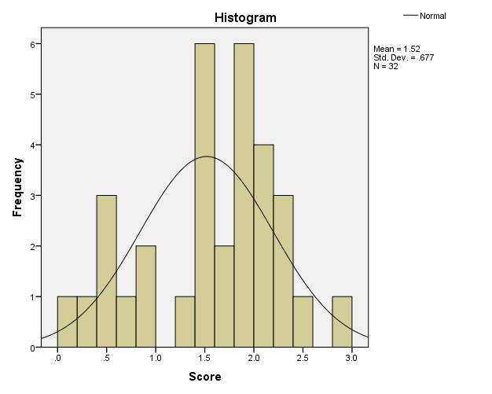

Step 2: Univariable Analysis

Table : Difference Performance Score between those with sleep and without sleep (n = 32)

|  |  |  |  |  |
| --- | --- | --- | --- | --- |
|  | With Sleep  mean (SD) | without sleep  mean (SD) | t-stat (df) | p-valuea |
|  |  |  |  |  |
| Performance Score | 1.99 (0.37) | 1.05 (0.59) | 5.41 (25.15) | < 0.001 |
|  |  |  |  |  |
| aWelch t-test | | | | |

Table 3: Difference Performance Score between those with alcohol and no alcohol (n = 32)

|  |  |  |  |  |
| --- | --- | --- | --- | --- |
|  | Yes Alcohol  mean (SD) | No Alcohol  mean (SD) | t-stat (df) | p-valuea |
|  |  |  |  |  |
| Performance Score | 1.16 (0.70) | 1.88 (0.43) | - 3.46 (24.70) | 0.002 |
|  |  |  |  |  |
| aWelch t-test | | | | |

Step 3: Model Fitting

|  |  |  |  |  |
| --- | --- | --- | --- | --- |
| **Descriptive Statistics** | | | | |
| Dependent Variable: Score | | | | |
| Sleep | Alcohol | Mean | Std. Deviation | N |
| With | Yes | 1.788 | .2997 | 8 |
| No | 2.188 | .3271 | 8 |
| Total | 1.988 | .3667 | 16 |
| Without | Yes | .538 | .2825 | 8 |
| No | 1.563 | .2446 | 8 |
| Total | 1.050 | .5877 | 16 |
| Total | Yes | 1.163 | .7042 | 16 |
| No | 1.875 | .4266 | 16 |
| Total | 1.519 | .6775 | 32 |

|  |  |  |  |
| --- | --- | --- | --- |
| **Levene's Test of Equality of Error Variancesa** | | | |
| Dependent Variable: Score | | | |
| F | df1 | df2 | Sig. |
| .197 | 3 | 28 | .898 |
| Tests the null hypothesis that the error variance of the dependent variable is equal across groups. | | | |
| a. Design: Intercept + Sleep + Alcohol | | | |

Between the main effect there was homogeneity

|  |  |  |  |  |  |
| --- | --- | --- | --- | --- | --- |
| **Tests of Between-Subjects Effects** | | | | | |
| Dependent Variable: Score | | | | | |
| Source | Type III Sum of Squares | df | Mean Square | F | Sig. |
| Corrected Model | 11.093a | 2 | 5.546 | 51.285 | .000 |
| Intercept | 73.811 | 1 | 73.811 | 682.511 | .000 |
| Sleep | 7.031 | 1 | 7.031 | 65.016 | .000 |
| Alcohol | 4.061 | 1 | 4.061 | 37.553 | .000 |
| Error | 3.136 | 29 | .108 |  |  |
| Total | 88.040 | 32 |  |  |  |
| Corrected Total | 14.229 | 31 |  |  |  |
| a. R Squared = .780 (Adjusted R Squared = .764) | | | | | |

In main effect model, both sleep and alcohol had significant effect on performance score.

Step 4: Checking Interaction

|  |  |  |  |  |  |
| --- | --- | --- | --- | --- | --- |
| **Tests of Between-Subjects Effects** | | | | | |
| Dependent Variable: Score | | | | | |
| Source | Type III Sum of Squares | df | Mean Square | F | Sig. |
| Corrected Model | 11.874a | 3 | 3.958 | 47.058 | .000 |
| Intercept | 73.811 | 1 | 73.811 | 877.586 | .000 |
| Sleep | 7.031 | 1 | 7.031 | 83.599 | .000 |
| Alcohol | 4.061 | 1 | 4.061 | 48.287 | .000 |
| Sleep * Alcohol | .781 | 1 | .781 | 9.289 | .005 |
| Error | 2.355 | 28 | .084 |  |  |
| Total | 88.040 | 32 |  |  |  |
| Corrected Total | 14.229 | 31 |  |  |  |
| a. R Squared = .834 (Adjusted R Squared = .817) | | | | | |

There was significant interaction between sleep and alcohol [F (1, 28) = 9.29, p = 0.005)

Step 5: Checking Model Assumption

* X is normally distributed at function of Y – residual normally distributed
* DV had equal variance across all group

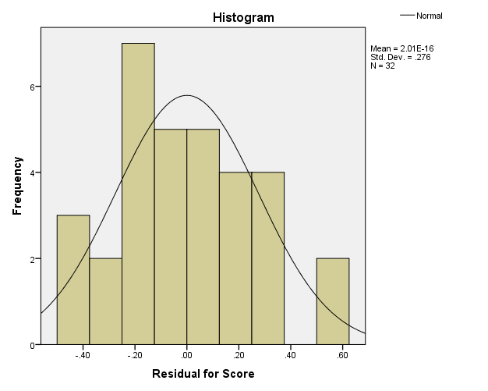

Figure : Histogram for Residual Score

Residual was normally distributed

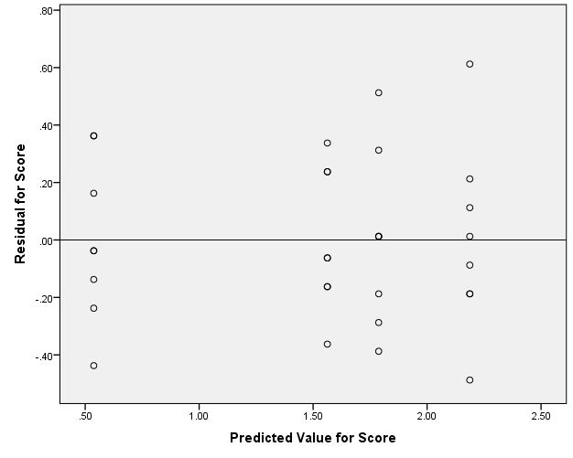

Figure : Scatter Plot between Predicted Score and Residual Score

Residual score scatter at Y = 0.

|  |  |  |  |
| --- | --- | --- | --- |
| **Levene's Test of Equality of Error Variancesa** | | | |
| Dependent Variable: Score | | | |
| F | df1 | df2 | Sig. |
| .057 | 3 | 28 | .982 |
| Tests the null hypothesis that the error variance of the dependent variable is equal across groups. | | | |
| a. Design: Intercept + Sleep + Alcohol + Sleep * Alcohol | | | |

Assumption for homogeneity was met.

Step 6: Post-hoc test

Since there is significant interaction between sleep and alcohol, the analysis will be done separately. In this answer, the analysis was done separately by sleep variable.

|  |  |  |  |  |  |
| --- | --- | --- | --- | --- | --- |
| **Estimates** | | | | | |
| Dependent Variable: Score | | | | | |
| Alcohol | Sleep | Mean | Std. Error | 95% Confidence Interval | |
| Lower Bound | Upper Bound |
| Yes | With | 1.788 | .103 | 1.577 | 1.998 |
| Without | .538 | .103 | .327 | .748 |
| No | With | 2.188 | .103 | 1.977 | 2.398 |
| Without | 1.563 | .103 | 1.352 | 1.773 |

|  |  |  |  |  |  |  |  |
| --- | --- | --- | --- | --- | --- | --- | --- |
| **Pairwise Comparisons** | | | | | | | |
| Dependent Variable: Score | | | | | | | |
| Sleep | (I) Alcohol | (J) Alcohol | Mean Difference (I-J) | Std. Error | Sig.b | 95% Confidence Interval for Differenceb | |
| Lower Bound | Upper Bound |
| With | Yes | No | -.400* | .145 | .010 | -.697 | -.103 |
| No | Yes | .400* | .145 | .010 | .103 | .697 |
| Without | Yes | No | -1.025* | .145 | .000 | -1.322 | -.728 |
| No | Yes | 1.025* | .145 | .000 | .728 | 1.322 |
| Based on estimated marginal means | | | | | | | |
| *. The mean difference is significant at the .05 level. | | | | | | | |
| b. Adjustment for multiple comparisons: Bonferroni. | | | | | | | |

|  |  |  |  |  |  |  |  |
| --- | --- | --- | --- | --- | --- | --- | --- |
| **Univariate Tests** | | | | | | | |
| Dependent Variable: Score | | | | | | | |
| Sleep | | Sum of Squares | df | Mean Square | F | Sig. | Partial Eta Squared |
| With | Contrast | .640 | 1 | .640 | 7.609 | .010 | .214 |
| Error | 2.355 | 28 | .084 |  |  |  |
| Without | Contrast | 4.203 | 1 | 4.203 | 49.966 | .000 | .641 |
| Error | 2.355 | 28 | .084 |  |  |  |
| Each F tests the simple effects of Alcohol within each level combination of the other effects shown. These tests are based on the linearly independent pairwise comparisons among the estimated marginal means. | | | | | | | |

Step 7: Presentation

Table : Descriptive Statistic

|  |  |  |  |  |
| --- | --- | --- | --- | --- |
|  |  |  | With Sleep | without Sleep |
|  |  | n | mean (SD) | mean (SD) |
| Alcohol | |  |  |  |
|  | Yes | 16 | 1.79 (0.30) | 0.54 (0.28) |
|  | No | 16 | 2.19 (0.33) | 1.56 (0.24) |

Table : ANOVA Summary for Performance score by alcohol consumption and sleep

|  |  |  |  |  |  |
| --- | --- | --- | --- | --- | --- |
| Source of variation | SS (df) | MS | F-stat | p-value | Effect size (η2)* |
|  |  |  |  |  |  |
| Sleep | 7.03 (1) | 7.03 | 83.60 | < 0.001 | 0.75 |
|  |  |  |  |  |  |
| Alcohol | 4.06 (1) | 4.06 | 48.29 | < 0.001 | 0.63 |
|  |  |  |  |  |  |
| Sleep * Alcohol | 0.78 (1) | 0.78 | 9.29 | 0.005 | 0.25 |
|  |  |  |  |  |  |
| Error | 2.36 (28) | 0.08 |  |  |  |
|  |  |  |  |  |  |
| R2 = 0.834; Adj. R2 = 0.817  Homogeneity of Regression and normality assumptions were met  *Effect size by partial eta-square | | | | | |

Table : Multiple Comparison of Performance Mean Differences (Simple Main Effects)

|  |  |  |  |  |  |  |
| --- | --- | --- | --- | --- | --- | --- |
| Variables | | Performance Score | | | | |
| Adj. Mean (SE)a | Adj. Mean Diff (95% CI)b | F-stat (df) | p-valuea | Effect size (η2) |
| With Sleep | |  |  |  |  |  |
|  | Alcohol Yes | 1.79 (0.10) | - 0.40 (- 0.70, - 0.10) | 7.61 (1, 28) | 0.010 | 0.21 |
|  | Alcohol No | 2.19 (0.10) |  |  |  |  |
|  |  |  |  |  |  |  |
| Without Sleep | |  |  |  |  |  |
|  | Alcohol Yes | 0.54 (0.10) | - 1.03 (- 1.32, - 0.73) | 49.97 (1, 28) | < 0.001 | 0.64 |
|  | Alcohol No | 1.56 (0.10) |  |  |  |  |
|  |  |  |  |  |  |  |
| a Adjusted mean using 2-way ANOVA  b Bonferroni adjustment for 95% CI for difference | | | | | | |

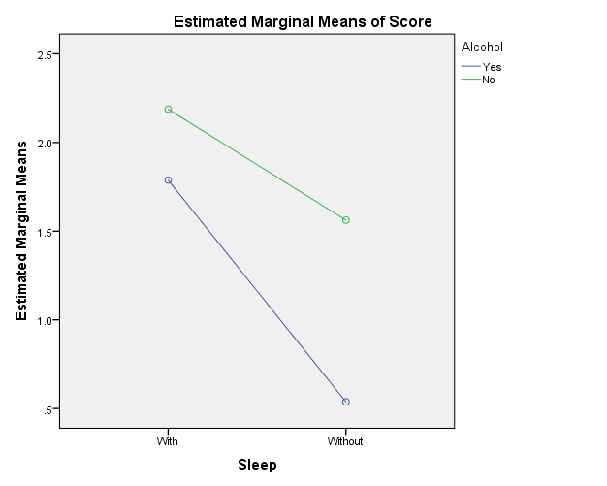

Figure : Estimated Marginal Mean Plot for Performance score between Sleep and Alcohol